Poster Abstract Submission Guidelines
- The authors must pre-register for the Annual Conference.
- All abstracts must be submitted via email to hrishikesh.sonalikar@binstitute.org
- Only complete Poster abstracts with all required information will be considered for presentation at the Annual Conference.
- The final submission deadline is February 13, 2019

General Guidelines to prepare your abstract
- Use only text. Do not use graphs, charts, diagrams, boxes, borders or tables.
- All abstracts must use correct grammar and punctuation. Proofread carefully for formatting, spelling and grammar.
- Authors should provide their abstract in Word format.
- Title of the abstract must be in CAPITAL LETTERS, and bolded, with no abbreviations.
- Title must be followed by names of authors.
- Provide the affiliation(s) for each author (department, organization, and the email address for the author(s).
- Abstract must be single spaced, Arial Font, size 11 and be a maximum of 500 words.
- Abstract must be formatted as per attached example: TITLE, Authors, Affiliation(s), Presenter(s) Email, Introduction, Rationale/Objectives, Methods, Results, Conclusions (bold these subtitles).

Clearly indicate which author(s) will be attending the conference and provide full contact information for each in the body of the email when submitting your abstract(s).
Abstracts will not be edited and will be reproduced in the form submitted in the souveneir to be distributed at the conference. Please proofread your abstract carefully because once submitted, it cannot be revised.

Selection Process
Abstracts will be reviewed according to 1) clarity, 2) scientific merit, 3) novelty of content, and 4) implications of research.
Submissions will be reviewed by the selection committee, whose members represent a variety of disciplines. Not all submissions for poster presentations will be selected and final decisions will rest with the selection committee. Researchers may be invited to present a poster presentation rather than an oral presentation. The participants will be notified by email regarding the status of their abstract by February 15, 2019.

Notice of Final Poster Acceptance
All the poster authors will be notified of their acceptance for presentation at the Annual Conference and poster preparation guidelines by February 15, 2019. A final poster listing, including assigned poster numbers and detailed presentation information, will also be made available by February 16, 2019.

Sample Abstract:

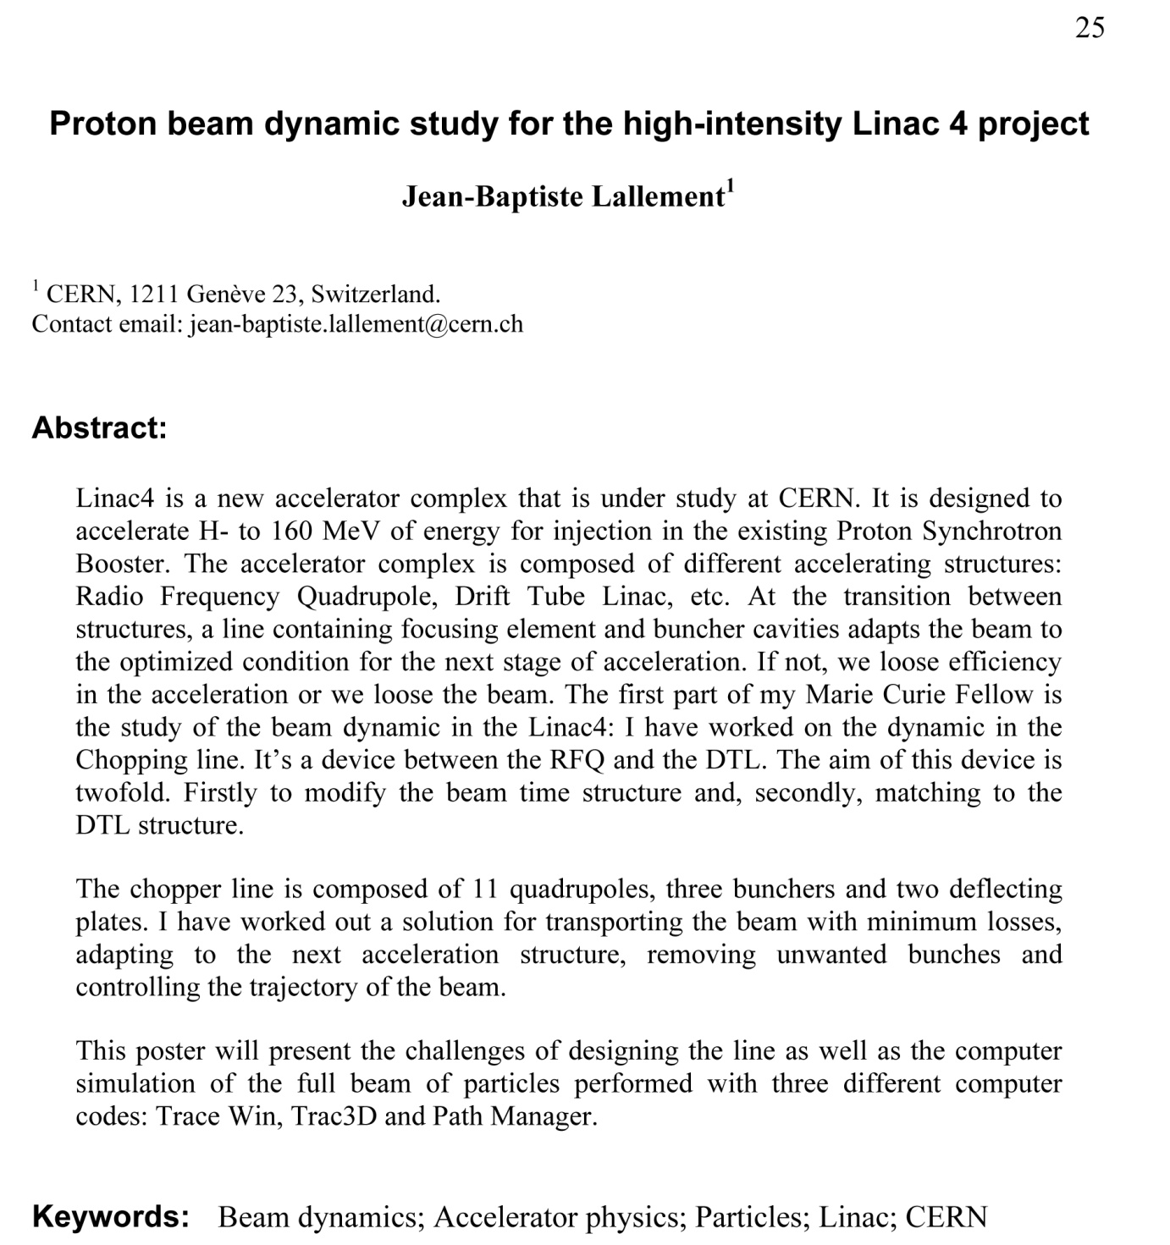

Poster Preparation and Presentation Guidelines
- Dimensions: Width = 35 inch, Height = 43 inch
- Use the font sizes given in the sample poster (a powerpoint (.ppt) file). You may like to use the same page-setup that of the sample poster. Please note that the smallest size texts have to be readable from a distance of approx 1 m.
- Presenting author has to be identified by writing his/her name “all in upper case” like: SUSHANTA SHARMA in the sample format (Format: first name / middle name / surname).
- Posters should stimulate discussion, not give a long presentation. Therefore, keep text to a minimum, emphasize graphics and make sure every item is necessary.
- Include the title of your presentation. .
- Use large and legible lettering that is easily readable from a distance of 3 feet or more. Text material should be printed through a laser printer with a font size large enough to read from a distance.
- Photographs, illustrations and graphics are encouraged, and should be large enough (with good resolution) to ensure visibility.
- Each selected poster will be provided a identification number which will be sent to the poster participants by email.
- Write paper number “finally assigned” to your paper on the top-left side in the same position as shown in the sample poster. In the sample poster it is AISSQ-2012:001.
- Authors are responsible for their poster display and takedown.
- Display materials may be affixed to the boards with push pins (provided on-site at the meeting.
- Setup will be between 8:00 am and 9:00 am, session will be between 1:00pm and 2:00pm.
- Extension cables for electric power will not be available near any of the poster boards. No PC/lab top will be made available to anyone to give any demo of his/her work. If one wants to give demo of his/her work, he/she must use his/her laptop and run it on battery backup. For charging laptops, one will find many power points.
- The presenting author has to be present near the poster for the entire duration of the particular poster session. Other authors may assist the presenting author in explaining the things.
- The presenting author has to be thorough with the work to generate interest in his/her work.
- You will be expected to present a 60 second overview of your poster to the conference audience at the lunch break. Creativity is encouraged to entice attendees to view your Poster
- Poster board dimensions will be provided upon confirmation of Committee approval
Optional Materials: The authors are encouraged to prepare and bring handouts for distribution to the delegates interested in their work.

AWARDS
- There will be 3 best poster awards (cash prize and certificate). The awardees will be selected by a panel of experts based on the poster content and interaction with the presenter (posters not attended by the presenters at their scheduled time will not be considered) and the award recipients will be announced during the conference.
- Authors of selected outstanding posters will be invited to submit extended versions of their papers for consideration of publication in the Journal of AOAC International.
selection committee
ABSTRACT GUIDELINES:
Abstracts must include sufficient information for reviewers to judge the nature and significance
of the topic, the adequacy of the investigative strategy, the nature of the results, and the
conclusions. The abstract should summarize the substantive results
of the work and
not
merely
list topics to be discussed.
An abstract is an outline/brief summary of your paper and your whole project. It should have an
intro, body and conclusion. It is a well
-
developed paragraph, should be
exact in wording, and must be
understandable to a wide audience. Abstracts should be no more
than 250 words, formatted in Microsoft Word, and single
-
spaced, using size 12 Times New
Roman font.
Abstracts
highlight major points of
your
research and explain
why your work is important
;
what
your purpose
was
, how you went about your project, what you learned, and what you
concluded.
If your title includes scientific notation, Greek letters, bold, italics, or other special
characters/symbols,
do
make sure they appear correctly.
List
all
additional undergraduate co
-
authors, whether they are
or are not presenting
, if
applicable.
List additional faculty mentors, if applicabl

